**E-WASTE MANAGEMENT SYSTEM**

# A PROJECT DISSERTATION REPORT

Submitted in partial fulfilment of the requirements for the award of the Degree of

**BACHELOR OF SCIENCE**

**(INFORMATION TECHNOLOGY)**

**By**

PRATIMA KAMBLE

SEAT NO.: 10

**Under the esteemed guidance of Mr. Bhupinder Singh.**



**DEPARTMENT OF INFORMATION TECHNOLOGY**

**SIDDHARTH COLLEGE OF ARTS, SCIENCE, COMMERCE**

**(***Affiliated to university of Mumbai***)**

**MUMBAI 400001**

**MAHARASHTRA**

**YEAR: 2019-2020**

**PROFORMA FOR THE APPROVAL OF PROJECT PROPOSAL**

***(Note: All entries of the proforma of approval should be filled up with appropriate and complete information. Incomplete proforma of approval in any respect will be summarily rejected.)***

PNR No.: 2017016400561611 Roll No.: 10

Name of the Student: PRATIMA P. KAMBLE

Title of the project: E-WASTE MANAGEMENT SYSTEM

Name of the Guide: Mr. BHUPINDER SINGH

Teaching experience of guide: 15 years

Is this your first submission? YES

NO

|  |  |  |  |
| --- | --- | --- | --- |
| Signature of student Date: | Signature Date: | of | guide |

Signature of coordinator Date:

**SIDDHARTH COLLEGE OF ARTS, SCIENCE,**

**COMMERCE**

**(***Affiliated to university of Mumbai***)**

**MUMBAI-MAHARASHTRA 400001**

**DEPARTMENT OF INFORMATION TECHNOLOGY**



**CERTTIFICATE**

This is to certify that the project entitled “**E-WASTE MANAGEMENT SYSTEM**” is bonafied work of **PRATIMA P.**

**KAMBLE** bearing **Seat no(10)** submitted in partial fulfilment of the requirement for the award of degree of **BACHELOR OF SCIENCE** in **INFORMATION TECHNOLOGY** from

University of Mumbai.

# Internal guide Coordinator

**External Examiner**

# Date: College seal

**ABSTRACT**

This project aims to provide another way for the customer to giving the E-waste material. The E-waste Collection System is and Internet based application that can be accessed throughout the Net and can be accessed by anyone who has a net connection. It s automatic system, where we will automate the selling of waste material and enquiries about which waste equipment are collection. After inserting the data to database, staff need not to worry about the orders received through the system and hence reduce the manual labour.

**ACKNOWLEDGEMENT**

We express sincere gratitude to the Prof. Bhupinder Singh and HOD of IT Department Mr. Javed Moosa and core faculty of Information Technology.

SIDDHARTH COLLEGE OF ARTS, SCIENCE, COMMERCE is the constant source of inspiration and guidance to us. Their valuable knowledge and experience helped us to get through all the difficulties.

I would also thank my friends for giving me the opinions and various inputs in long discussion on the project which helped me shape the website keeping in mind the user friendly.

I would also like to thank everyone helped me in my project in some way or other which includes providing me with some information.

**DECLARATION**

I here by declare the project entitled, “E-WASTE COLLECTION SYSTEM” done by Pratima Kamble , has not been in any case duplicated to submit to any other university for the award of an degree. To the best of my knowledge other than me, no one has submitted to any other university.

The project is done in partial fulfilment of the requirements for the award

# of degree of BACHELOR OF SCIENCE (INFORMATION

**TECHNOLOGY)** to be submitted as final semester project as part of our curriculum.

**PRATIMA P. KAMBLE**

**TABLE CONTENT**

# CHAPTER 1: INTRODUCTION

## 1.1 Background……………………………………………...…..08

## 1.2 Objectives……………………………………………………09

## 1.3 Purpose, Scope and Applicability…………………….…....09

### 1.3.1 Purpose………………………………………………..09

### 1.3.2 Scope………………………………………………….10

### 1.3.3 Applicability…………………………………………..10

## 1.4 Organization Report…………………………………………11 CHAPTER 2: SURVEY OF TECHNOLOGY……………...12 CHAPTER 3: REQUIREMENT & SPECIFICATION

## 3.1 Problem Definition…………………………………………15

## 3.2 Requirement Specification………………………………...15

## 3.3 Planning & Scheduling…………………………………….15

## 3.4 Software & Hardware Requirement……………………...16

3.4.1 Software Requirement **…………………………..……16**

3.4.2 Hardware Requirement**………………………………..16**

## 3.5 Preliminary Product Description………………………….16

## 3.5 Conceptual Model…………………………………………..17

3.6.1 Data Flow Diagram**……………………………………17**

### 3.6.2 ER Diagram……………………………………………19

3.6.3 Class Diagram**…………………………………………20**

### 3.6.4 Gantt Char……………………………………………..21

### 3.6.5 Pert Chart………………………………………………22

# CHAPTER 4: SYSTEM DESIGN

## 4.1 Basic Module………………………………………….23

## 4.2 Data Design……………………………………………24

4.2.1 Schema Design**………………………………….24**

4.2.2 Data Integrity and Constraints**…………………..25**

## 4.3 Procedural Design…………………………………………..27

4.3.1 Logical Diagrams**…………………………………….27**

4.3.2 Data Structure**………………………………………..35**

4.3.2 Algorithm Design**……………………………………36**

## 4.4 User Interface Design………………………………………….37 4.5 Security Issue…………………………………………………..39

# 4.6Test Case Design……………………………………………….39

**CHAPTER 1**

**INTRODUCTION**

**“E-waste Collection System**” as a Website Management System which create Admin and user database. This module allows admin to login and view the total new customers and the customer logged in can also see the feedback and the their request status. It is used for the collection of the electronic waste material from the customer, local collector, so on. The customer can define the details about which type of waste having by logged in. The customer can get the money by giving the waste material. E-waste Collection System is for developers and recycling it in the company. This module also assigns login rights to both user and admin.

E-waste Collection System covers all types of E-waste in integrative manner from all the waste source including E-waste from domestic/municipal and industrial sources. As a part of E-waste Collection System, is focusing on electronic waste management. This work will complement the work being done, globally and regionally on E-waste by secretaries of multilateral environmental agreement in particular the secretaries of Basel Convention

## 1.1 BACKGROUND:-

"**E-waste**" is a popular, informal name for electronic products nearing the end of their "useful life. "E-wastes are considered dangerous, as certain components of some electronic products contain materials that are hazardous, depending on their condition and density. The hazardous content of these materials pose a threat to human health and environment. Discarded computers, televisions, VCRs, stereos, copiers, fax machines, electric lamps, cell phones, audio equipment and batteries.

Electronic wastes contain toxic substances such as lead, mercury, cadmium, and lithium. These toxic materials can be released upon disposal, posing a threat to human health and the environment. Inconsistencies in worker safety and environmental protection mean potential liability concerns for those sending electronics to recycling facilities.

## 1.2 OBJECTIVES:-

The major object of project is to build capacity of practitioners and decision makers to guide and handhold them to plan, design and implement online E-waste Collection System including policy, Collection, transportation and treatment in a city/ geographical area and country. Encourage and promote the development and progress of E-waste Collection System towards achieving in the field of computer sciences and technology for theatre applications both for recycling and deployment of electronic waste.

Online E-waste Collection System amongst client for awareness and recycling of the waste material by using latest system. Simulation and offer aid for system for the benefit of manufactures and users. Help in the improvement of standards, terminology equipment’s, methods and implementation practices in the field of E-waste Collection System.

## 1.3 PURPOSE, SCOPE & APLICABILITY :-

### 1.3.1 PURPOSE:-

The main purpose of E-waste Collection System is to provide another way for the customer to giving the E-waste material. The E-waste Collection System is and internet based application that can be accessed throughout the Net and can be accessed by anyone who has a internet connection. It is an automatic system, where we will automate the selling of waste electronic material and enquiries about which waste equipment are collection. After inserting the data to database, staff need not to worry about the orders received through the system and hence reduce the manual labour. One of the best features of the system is to deploy or recycling the electronic equipment from the customer house and the city.

The goals of system are:

* To provide anytime anyplace service for the customer.
* To reuse electronic waste material by recycling or deploy.
* To decrease the electronic waste material from household.
* To obtain static information about the problems effect by the e- waste material.
* To provide awareness about electrical and electronic material using for household.

### 1.3.2 SCOPE:-

The scope of the project is to provide approaches and strategies which have proved to be the suitable when assessing the e-waste system of the defined region. This collection will reduce the e-waste from the household, company, industries, city, etc. The environment pollution will reduce and the electronic waste will recycle or deploy. The fundamental aims of the **Basel Convention** are the control and reduction of trans boundary movements of hazardous and other waste including the prevention and minimization of their generation, the environmentally sound management of such waste and the active promotion of the transfer and use of technologies.

This technique could eliminate waste disposal costs, reduce raw material costs and provide income from a saleable waste. Waste can be recovered on- site, or at an off-site recovery facility, or through inter industry exchange. A number of physical and chemical techniques are available to reclaim a waste material such as reverse osmosis, electrolysis, condensation, electrolytic recovery, filtration, centrifugation etc. for example, a printed circuit board manufacturer can electrolytic recovery to reclaim metals from copper and tin-lead platin.

### 1.3.3 APPLICABILITY:-

We offer progressive end-to-end solutions keeping in mind to maintain the specific data of contact us form, feedback form, upcoming event.

Services They Provide: -

* Maintaining the user’s information. • Maintaining the waste information.
* To keep track on all the recycle data and deploy for E-waste.
* To add/update/delete the user data.
* To add/update/delete the requested data.
* To add/update/delete the event data.
* Password reset mailing Feedback mail.

## 1.4 ORGANIZATION OF REPORT :-

The current chapter explains what the project is all about. Second chapter will explains the planning of the project and its development, its requirement its tasks and all the requirements, such as hardware and software requirements. The planning of resources and application to be used in the project will be decided. Once the project functionality will be explained with required flow diagrams, process diagrams etc. The data structure of the project and functionality will be explained. Algorithm designs with input data, output data and logic and design will also be explained.

**CHAPTER 2**

**SURVEY OF TECHNOLOGY**

## 2.1 ABOUT VISUAL STUDIO 2010:-

* First of all, VB.NET provides managed code execution that runs under the Common Language Runtime (CLR), resulting in robust, stable and secure applications. All features of the .NET framework are readily available in VB.NET.
* VB.NET is totally object oriented. This is a major addition that VB6 and other earlier releases didn't have.
* The .NET framework comes with ADO.NET, which follows the disconnected paradigm, i.e. once the required records are fetched the connection no longer exists. It also retrieves the records that are expected to be accessed in the immediate future. This enhances Scalability of the application to a great extent.
* VB.NET uses XML to transfer data between the various layers in the DNA Architecture i.e. data are passed as simple text strings.
* Error handling has changed in VB.NET. A new Try-Catch-Finally block has been introduced to handle errors and exceptions as a unit, allowing appropriate action to be taken at the place the error occurred thus discouraging the use of ON ERROR GOTO statement. This again credits to the maintainability of the code.
* Another great feature added to VB.NET is free threading against the VB single-threaded apartment feature. In many situations developers need spawning of a new thread to run as a background process and increase the usability of the application. VB.NET allows developers to spawn threads wherever they feel like, hence giving freedom and better control on the application.
* Security has become more robust in VB.NET. In addition to the role- based security in VB6, VB.NET comes with a new security model, Code Access security. This security controls on what the code can access. For example, you can set the security to a component such that the component cannot access the database. This type of security is important because it allows building components that can be trusted to various degrees.
* The CLR takes care of garbage collection i.e. the CLR releases resources as soon as an object is no more in use. This relieves the developer from thinking of ways to manage memory. CLR does this for them.

## 2.2 ABOUT ASP.NET:-

ASP.NET is a web development platform, which provides a programming model, a comprehensive software infrastructure and various services required to build up robust web applications for PC, as well as mobile devices.

ASP.NET works on top of the HTTP protocol, and uses the HTTP commands and policies to set a browser-to-server bilateral communication and cooperation.

ASP.NET is a part of Microsoft .Net platform. ASP.NET applications are compiled codes, written using the extensible and reusable components or objects present in .Net framework. These codes can use the entire hierarchy of classes in .Net framework.

The ASP.NET application codes can be written in any of the following languages:

* C#
* Visual Basic.Net
* Jscript
* J#

ASP.NET is used to produce interactive, data-driven web applications over the internet. It consists of a large number of controls such as text boxes, buttons, and labels for assembling, configuring, and manipulating code to create HTML pages.

## 2.3 ABOUT C#:-

C# is a general object-oriented programming (OOP) language for networking and Web development. C# is specified as a common language infrastructure (CLI) language.

In January 1999, Dutch software engineer Anders Hejlsberg formed a team to develop C# as a complement to Microsoft’s NET framework. Initially, C# was developed as C-Like Object Oriented Language (Cool). The actual name was changed to avert potential trademark issues. In January

2000, NET was released as C#. Its NET framework promotes multiple Web technologies. The term is sometimes spelled as C Sharp or C-Sharp.

## 2.4 ABOUT MYSQL SERVER:-

# MySQL is an Oracle-backed open source relational database management system [(RDBMS)](https://searchdatamanagement.techtarget.com/definition/RDBMS-relational-database-management-system) based on Structured Query Language

[(SQL)](https://searchsqlserver.techtarget.com/definition/SQL). MySQL runs on virtually all platforms, including [Linux,](https://searchdatacenter.techtarget.com/definition/Linux-operating-system) [UNIX a](https://searchdatacenter.techtarget.com/definition/Unix)nd [Windows.](https://searchwindowsserver.techtarget.com/definition/Windows) Although it can be used in a wide range of applications, MySQL is most often associated with web applications and online publishing.

MySQL is an important component of an open source enterprise stack called [**LAMP**.](https://whatis.techtarget.com/definition/LAMP-Linux-Apache-MySQL-PHP) LAMP is a web development platform that uses Linux as the operating system, [Apache a](https://whatis.techtarget.com/definition/Apache)s the web server, MySQL as the relational database management system and [PHP a](https://whatis.techtarget.com/definition/PHP-Hypertext-Preprocessor)s the object-oriented scripting language.

Originally conceived by the Swedish company MySQL AB, MySQL was acquired by Sun Microsystems in 2008 and then by Oracle when it bought Sun in 2010. Developers can use MySQL under the GNU General Public License ([GPL)](https://searchdatacenter.techtarget.com/definition/GNU-General-Public-License-GNU-GPL-or-simply-GPL), but enterprises must obtain a commercial license from Oracle.

MySQL is based on a [client-server m](https://searchnetworking.techtarget.com/definition/client-server)odel. The core of MySQL is MySQL server, which handles all of the database instructions (or commands). MySQL server is available as a separate program for use in a client-server networked environment and as a library that can be embedded (or linked) into separate applications.

MySQL operates along with several utility programs which support the administration of MySQL databases. Commands are sent to MySQL Server via the MySQL client, which is installed on a computer.

MySQL was originally developed to handle large databases quickly. Although MySQL is typically installed on only one machine, it is able to send the database to multiple locations, as users are able to access it via different MySQL client interfaces. These interfaces send SQL statements to the server and then display the results.

**CHAPTER 3**

**REQUIREMENTS & ANALYSIS**

## 3.1 PROBLEM DEFINITION :-

* The existing system has one ways of waste collection system.
* The waste collection system is offline which is done by the government, like the waste material with all the mixture with solid and liquid waste. The waste is send to the garbage factories for the deployment of the waste.

## 3.2 REQUIREMENT SPECIFICATION :-

The waste collection system is now online waste collection website. The public get the information about the e-waste material and aware about the waste. We will collect the household electronic and electric equipment from the public and which will recycle or deploy waste. The recycling waste will be used in the other equipment’s, and industries can use the recycling equipment’s for new material, etc**.**

The goals of the system are:

* To provide anytime anyplace service for the customer.
* To reuse electronic waste material by recycling or deploy.
* To decrease the electronic waste material from household.
* To obtain statistic information about the problems effect by e-waste material.

## 3.3 PLANNING & SCHEDULING :-

* The purpose of project planning is to identify the scope of the project, estimate the work involved. Project planning begins with requirements that define the software to be developed. The project plan developed to the tasks that will lead to completion.
* Planning is the most important matter in any kind of work whether it is computerized or not. While for computerized system development, planning is very first and most important requirement.
* I have planned for my project as per follow:
  + Very first after deciding the topic for the project, I started to collect the related information for the project.
  + By collecting information, I decided about that and project is divided in specific time duration. So timing is also most necessary requirement for planning.
  + I also found different resources for gathering information about diamonds and all related tasks. And at last I start to work as per the planning and all tasks are completed one by one.

## 3.4 SOFTWARE and HARDWARE REUIREMENT :-

### 3.4.1 HARDWARE REQUIREMENT :

Processor : multiple core processor

RAM: 4GB

### 3.4.2 SOFTWARE REUIREMENT:

Web Browser: Mozilla Firefox, Chrome, Opera

## 3.5 PRELIMINARY PRODUCT DESCRIPTION :-

Preliminary investigation helps in clarification, understanding and evaluation of the project request. Preliminary investigation basically refers to the collection of information that guides the management of an organisation to evaluate the merits and demerits of the adoption request and make informed judgement of about the feasibility of their project aim.

For this report, we conducted the preliminary investigation by using:

1. The document provided by the local common people.
2. The requirements of the user searching in the website.

## 3.6 CONCEPTUAL MODELS :-

To understand the problem domain and produce a model of the system, which describes operations that can be performed on the system, and the allowable sequences of those operations.

### 3.6.1 DATA FLOW DIAGRAMS :-

A data flow diagram (DFD) illustrates how data is processed by a system in terms of inputs and outputs. As its name indicates, its focus is on the flow of information, where data comes from, where it goes and how it gets stored.

# Level 0 Diagram :

* Shows all the processes that comprise the overall system.
* Shows how information moves from and to each process.
* Adds data stores.

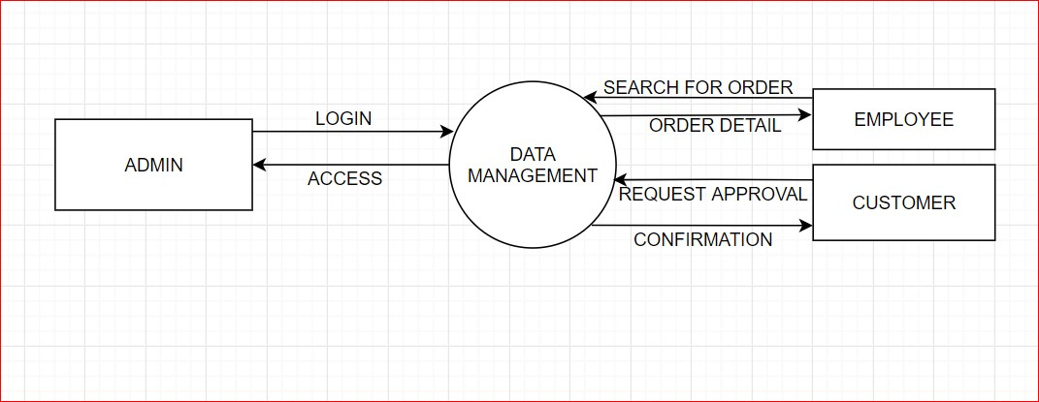

# Level 1 Diagram :

* Shows all the processes that comprise a single process on the level 0 diagram.
* Shows how information moves from and to each of these processes.
* Shows in more detail the content of higher level process.
* Level 1 diagrams may not be needed for all level 0 processes.

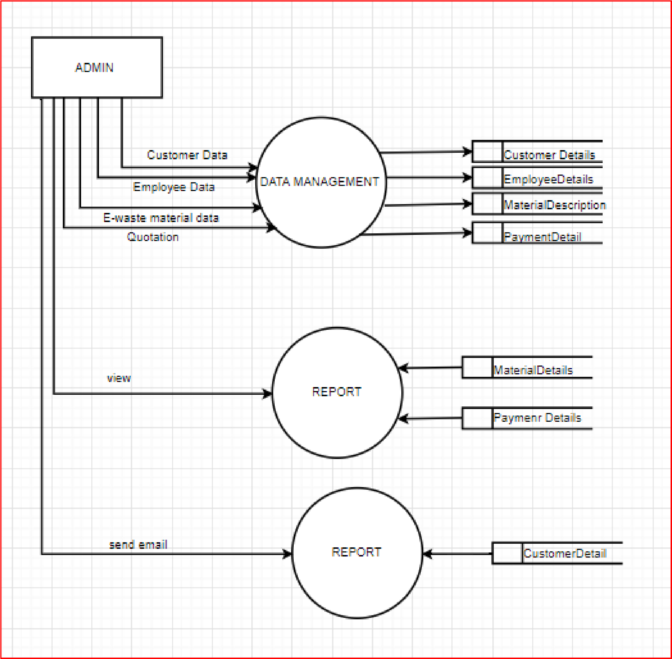

### 3.6.2 ER DIAGRAM :-

An Entity Relationship (ER) Diagram is a type of flowchart that illustrates how “entities” such as people, objects or concepts relate to each other within a system. ER Diagrams are most often used to design or debug relational databases in the fields of software engineering, business information systems, education and research. Also known as ERDs or ER Models, they use a defined set of symbols such as rectangles, diamonds, ovals and connecting lines to depict the interconnectedness of entities, relationships and their attributes. They mirror grammatical structure, with entities as nouns and relationships as verbs.

ER diagrams are related to data structure diagrams (DSDs), which focus on the relationships of elements within entities instead of relationships between entities themselves. ER diagrams also are often used in conjunction with data flow diagrams (DFDs), which map out the flow of information for processes or systems.

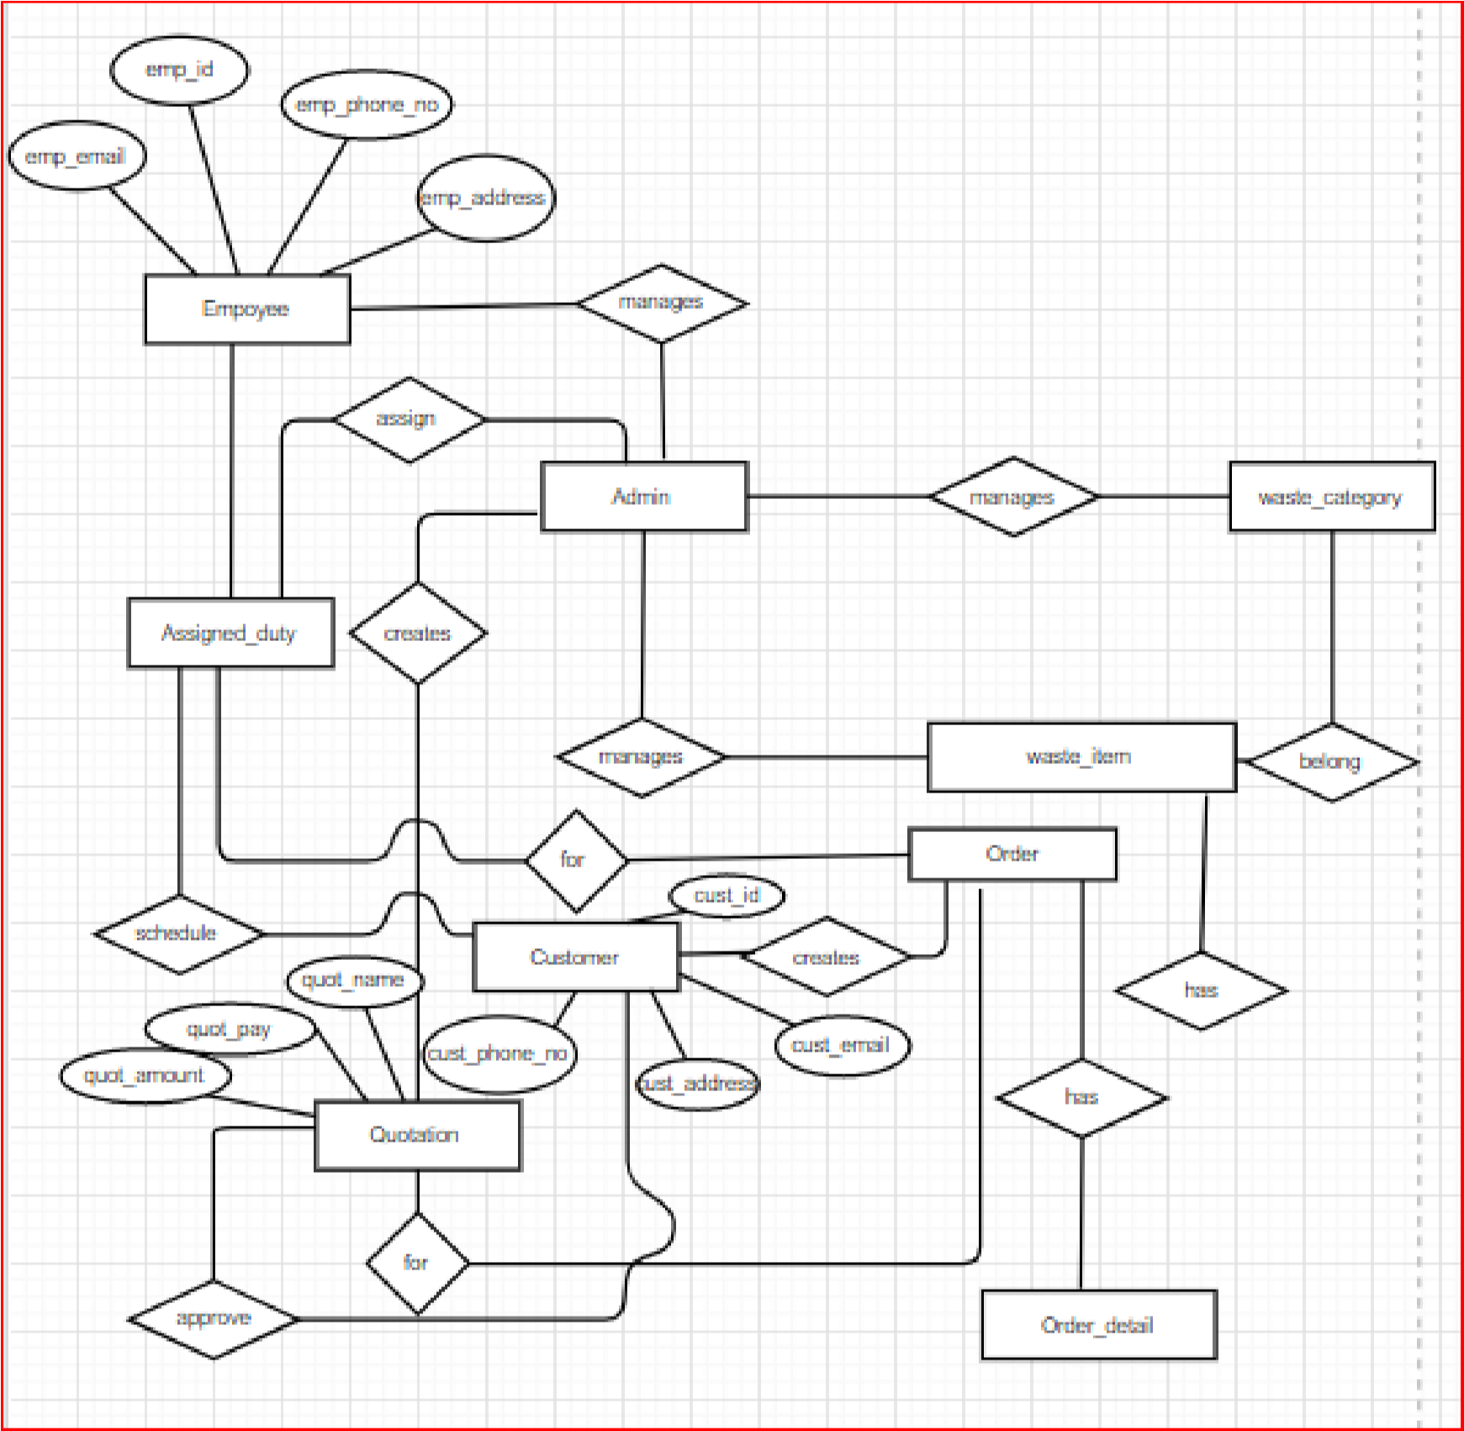

### 3.6.3 CLASS DIAGRAM :-

Class diagram is a static diagram. It represents the static view of an application. Class diagram is not only used for visualizing, describing, and documenting different aspects of a system but also for constructing executable code of the software application.

Class diagram describes the attributes and operations of a class and also the constraints imposed on the system. The purpose of class diagram is to model the static view of an application.

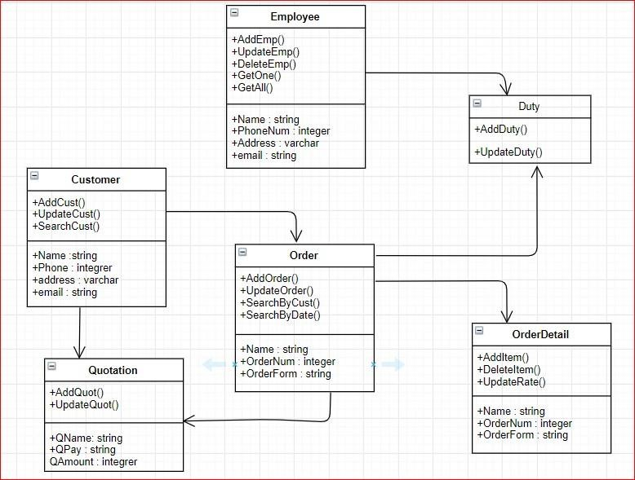

### 3.6.4 GANTT CHART :-

Gantt charts illustrate the start and finish dates of the terminal elements and summary elements of a project. Terminal elements and summary elements comprise the work breakdown structure of the project. Modern Gantt charts also show the dependency (i.e., precedence network) relationships between activities.

* Gantt charts can be used to show current schedule status using percent- complete shadings and a vertical "TODAY" line.

* Although now regarded as a common charting technique, Gantt charts were considered revolutionary when first introduced. This chart is also used in information technology to represent data that have been collected.

* Gantt charts can be used for scheduling generic resources as well as for their use in project management. They can also be used for scheduling adoption processes and employee rostering.

15

/Jul

04

/Aug

24

/Aug

13

/Sep

03

/Oct

23

/Oct

12

/Nov

Documentation

requirment

gathering

Analysis

Design

start date

duration

### 3.6.5 PERT CHART :-

A PERT chart is a project management tool used to schedule, organize, and coordinate tasks within a project. PERT stands for *Program Evaluation Review Technique*, a methodology developed by the U.S. Navy in the 1950s to manage the Polaris submarine missile program. A similar methodology, the *Critical Path Method* (CPM) was developed for project management in the private sector at about the same time.

The PERT chart is sometimes preferred over the [Gantt chart,](https://searchsoftwarequality.techtarget.com/definition/Gantt-chart) another popular project management charting method, because it clearly illustrates task dependencies. On the other hand, the PERT chart can be much more difficult to interpret, especially on complex projects. Frequently, project managers use both techniques.

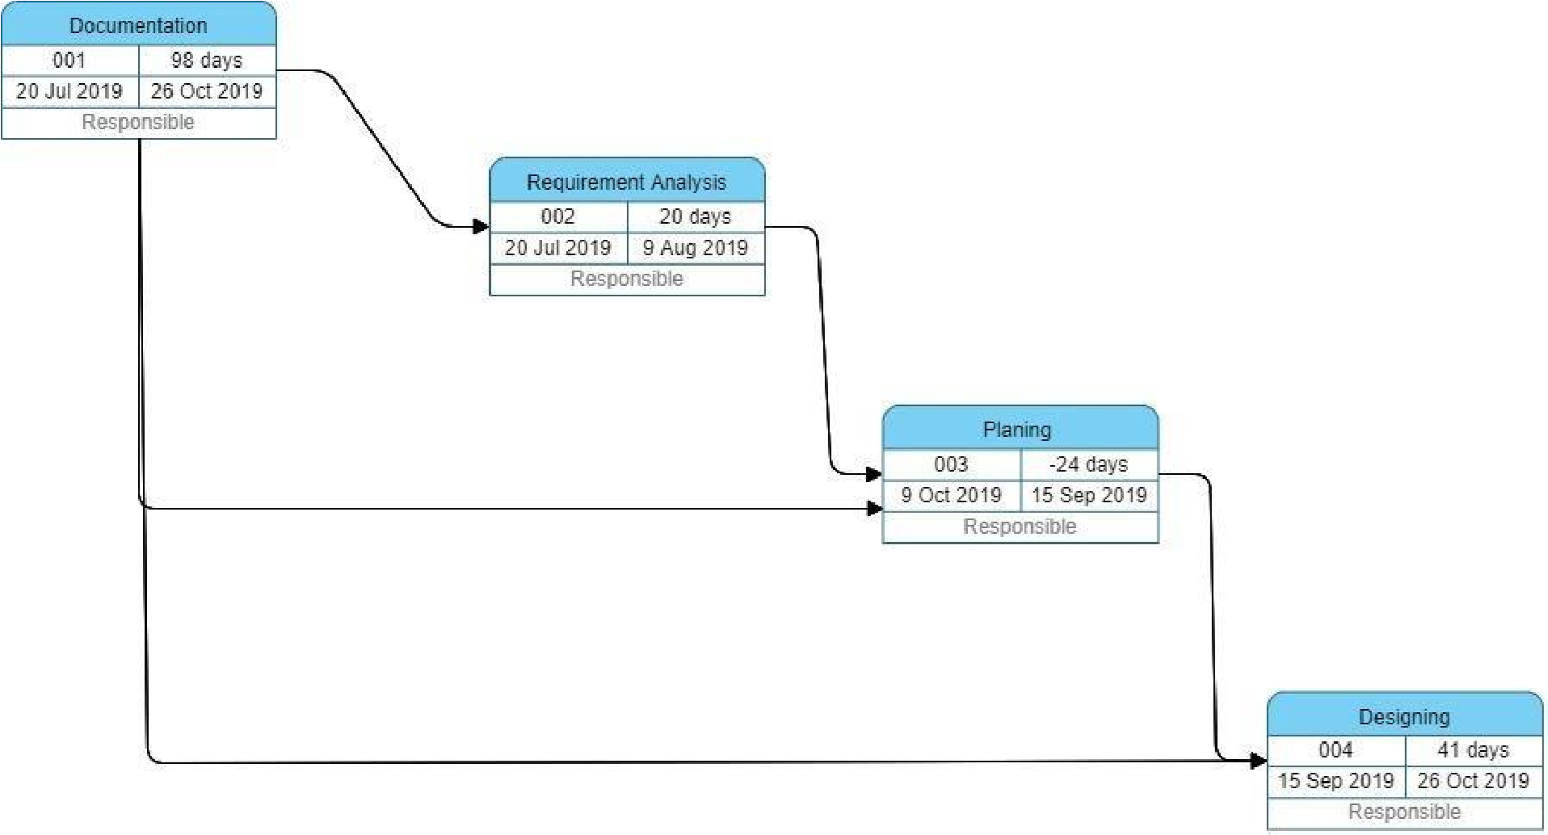

**CHAPTER 4**

**SYSTEM DESIGN**

## 4.1 BASIC MODULE:- LOGIN:

A login generally required the user to enter two pieces of information, first a user name and then a password. This information is enter into a login window on a GUI(Graphical User Interface) or on the command line in a console depending on the system.

A user name, also referred to as an account name, is string(i.e. sequence of characters) that uniquely identifies a user. User name can be same as or related to real names of user, or they can be completely arbitrary.

A password is likewise a string, but it differs from a user in that it is intended to be kept a secret that is known only to its user and, perhaps to the system administrator.

# ADMIN LOGIN:

Admin page has following module like Change password, View Ewaste, view detail of new registered user, View order and Approve. Admin can view the order which are put up for collection. Admin can see total number of new users who has registered to his/her website. Admin can see all the order details. Admin can see total number of orders which are completed or pending. He can view all the detail of the user or customer.

# USER LOGIN:

A login, logging in or logging on is the entering of the identifier information into a system by a user in order to access that system ( computer or website).

# NEW USER:

This module is for the users who do not have their account. Here user is allowed to create an account to login. The account creation is done by filling the registration form with user details such as name, phone, email, address etc.

## 4.2 DATA DESIGN:-

Database design is the organization of data according to a database model. The designer determine what data must be stored and how the data elements interrelate. With this information they can being to fit the data to the database model. Database design involves classifying data and identifying interrelationship.

### 4.2.1 SCHEMA DESIGN :-

The **database schema** of a database system is its structure described in a [formal language s](https://en.wikipedia.org/wiki/Formal_language)upported by the [database management system (](https://en.wikipedia.org/wiki/Database_management_system)DBMS). The term "[schema"](https://en.wiktionary.org/wiki/schema) refers to the organization of data as a blueprint of how the database is constructed (divided into database tables in the case of [relational databases)](https://en.wikipedia.org/wiki/Relational_databases). The formal definition of a [database s](https://en.wikipedia.org/wiki/Database)chema is a set of formulas (sentences) called integrity constraints [i](https://en.wikipedia.org/wiki/Integrity_constraints)mposed on a database. These integrity constraints ensure compatibility between parts of the schema. All constraints are expressible in the same language. A database can be considered a structure in realization of the [database language.](https://en.wikipedia.org/wiki/Database_language) The states of a created [conceptual schema a](https://en.wikipedia.org/wiki/Conceptual_schema)re transformed into an [explicit mapping,](https://en.wikipedia.org/wiki/Explicit_and_implicit_methods) the database schema. This describes how real-world entities are modeled in the database.

"A database schema specifies, based on the database administrator['s](https://en.wikipedia.org/wiki/Database_administrator) knowledge of possible applications, the facts that can enter the database, or those of interest to the possible [end-users.](https://en.wikipedia.org/wiki/End-user)" The notion of a database schema plays the same role as the notion of theory in [predicate calculus.](https://en.wikipedia.org/wiki/Predicate_calculus) A model of this "theory" closely corresponds to a database, which can be seen at any instant of time as a [mathematical object.](https://en.wikipedia.org/wiki/Mathematical_object) Thus a schema can contain formulas representing [integrity constraints s](https://en.wikipedia.org/wiki/Data_integrity#Types_of_integrity_constraints)pecifically for an application and the constraints specifically for a type of database, all expressed in the same database language. In a [relational database,](https://en.wikipedia.org/wiki/Relational_database) the schema defines the [tables,](https://en.wikipedia.org/wiki/Table_(database)) [fields,](https://en.wikipedia.org/wiki/Field_(computer_science)) [relationships,](https://en.wikipedia.org/wiki/Relational_model) [views,](https://en.wikipedia.org/wiki/View_(database)) [indexes,](https://en.wikipedia.org/wiki/Index_(database)) [packages,](https://en.wikipedia.org/wiki/Software_package_(installation)) [procedures,](https://en.wikipedia.org/wiki/Stored_procedure) [functions,](https://en.wikipedia.org/wiki/Subroutine) [queues,](https://en.wikipedia.org/wiki/Queue_(data_structure)) [triggers,](https://en.wikipedia.org/wiki/Database_trigger) [types,](https://en.wikipedia.org/wiki/Data_type) [sequences,](https://en.wikipedia.org/wiki/Sequence) materialized view[s,](https://en.wikipedia.org/wiki/Materialized_view) [synonyms,](https://en.wikipedia.org/wiki/Synonym_(database)) database links, [directories,](https://en.wikipedia.org/wiki/Directory_(file_systems)) [XML schemas,](https://en.wikipedia.org/wiki/XML_schema) and other elements.

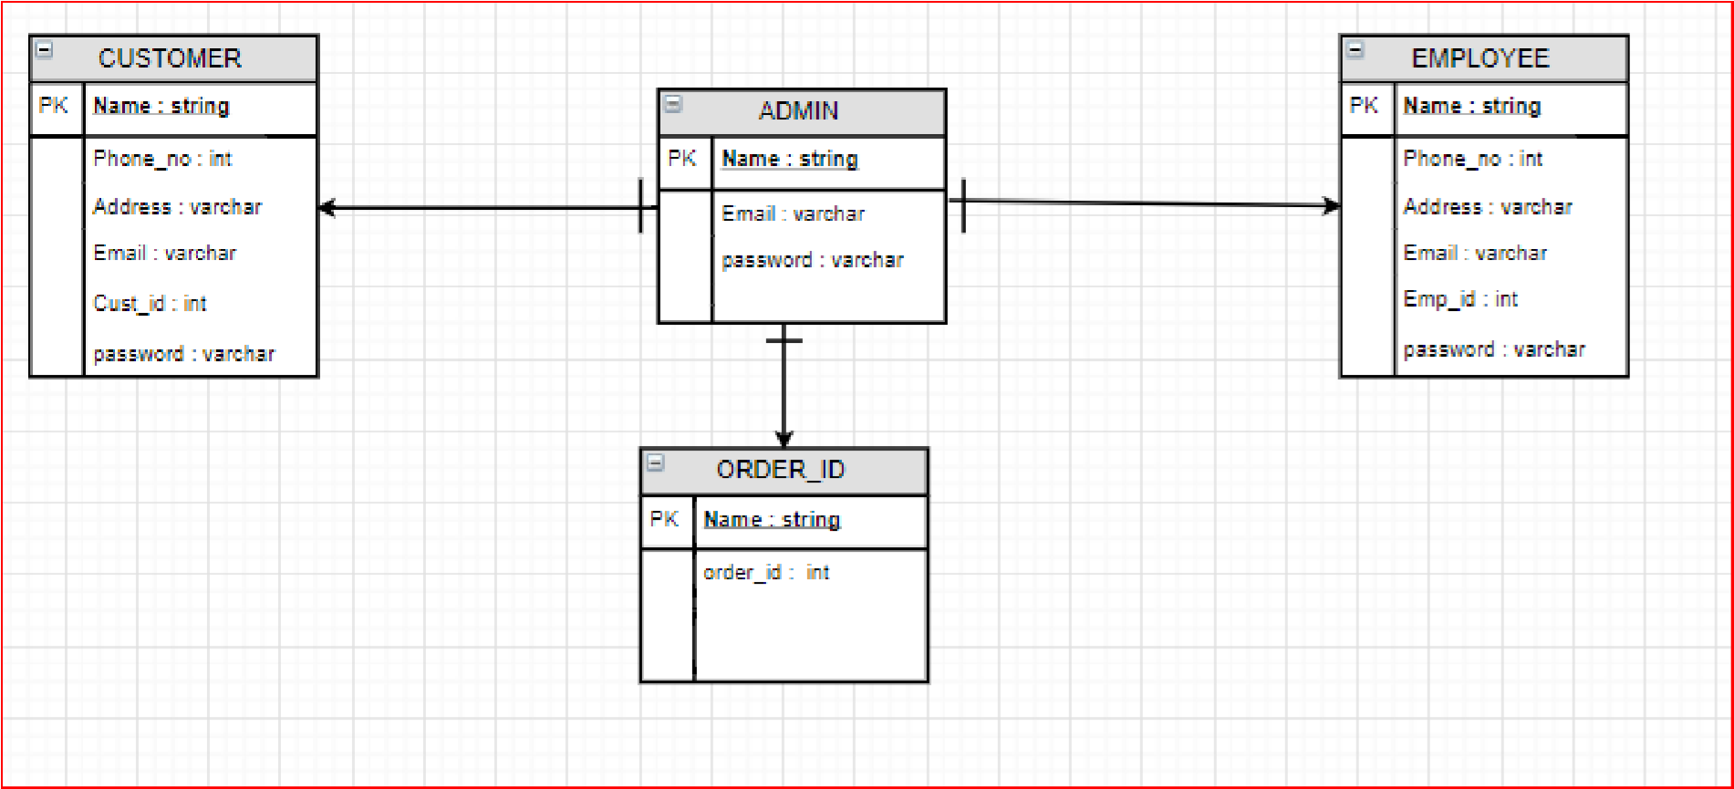

### 4.2.2 DATA INTEGRITY & CONSTRAINTS :

* Customer Table :

|  |  |  |
| --- | --- | --- |
| Column name | Data type | Constraints |
| Cust_id | Int | Unique, primary key |
| Name | Varchar | Not null |
| Contactc_no | Int | Not null |
| Address | Varchar | Not null |
| Email | Varchar | Not null |

* Admin Table:

|  |  |  |
| --- | --- | --- |
| Column name | Data type | Constraints |
| Admin_name | varchar | not null |
| admin_pass | string | not null |
| Contact_no | int | not null |

* Employee Table:

|  |  |  |
| --- | --- | --- |
| Column name | Data type | Constraints |
| email | string | not null |
| emp_id | int | unique, Primary key |
| Emp_name | varchar(40) | not null |

* Request:

|  |  |  |
| --- | --- | --- |
| Column name | Data type | Constraints |
| req_id | Int | Unique, primary key |
| Order_date | Int | Not null |
| E-waste_type | Varchar | Not null |
| status | Varchar | Not null |

## 4.2 PROCEDURAL DESIGN :-

Component level design also called procedural designoccurs after data, architectural and interface designs have been established.

Data, architectural and interface design must be translated into operational software. To accomplish this design must be represented at a level of abstraction that is close to code.

Component-level design establishes:-

* The algorithmic detail required to manipulate data structures.
* Effect communication between software components via their interfaces, and • Implement the processing algorithms allocated to each components.

### 4.2.1 LOGICAL DIAGRAMS :- CONTROL FLOW CHART:

A control-flow diagram can consist of a subdivision to show sequential steps, with if-then-else conditions, repetition, and/or case conditions. Suitably annotated geometrical figures are used to represent operations, data, or equipment, and arrows are used to indicate the sequential flow from one to another.

There are several types of control-flow diagrams, for example:

* Change-control-flow diagram, used in [project management](https://en.wikipedia.org/wiki/Project_management)
* Configuration-decision control-flow diagram, used in [configuration management](https://en.wikipedia.org/wiki/Configuration_management)
* [Process-control-](https://en.wikipedia.org/wiki/Process_control)flow diagram, used in [process management](https://en.wikipedia.org/wiki/Process_management) • Quality-control-flow diagram, used in [quality control.](https://en.wikipedia.org/wiki/Quality_control)

In software and systems development, control-flow diagrams can be used in [control-flow analysis,](https://en.wikipedia.org/wiki/Control-flow_analysis) [data-flow analysis,](https://en.wikipedia.org/wiki/Data-flow_analysis) [algorithm analysis,](https://en.wikipedia.org/wiki/Algorithm_analysis) and [simulation.](https://en.wikipedia.org/wiki/Simulation)

Control and data are most applicable for real time and data-driven systems. These flow analyses transform logic and data requirements text into graphic flows which are easier to analyze than the text. PERT, state transition, and transaction diagrams are examples of control-flow diagrams

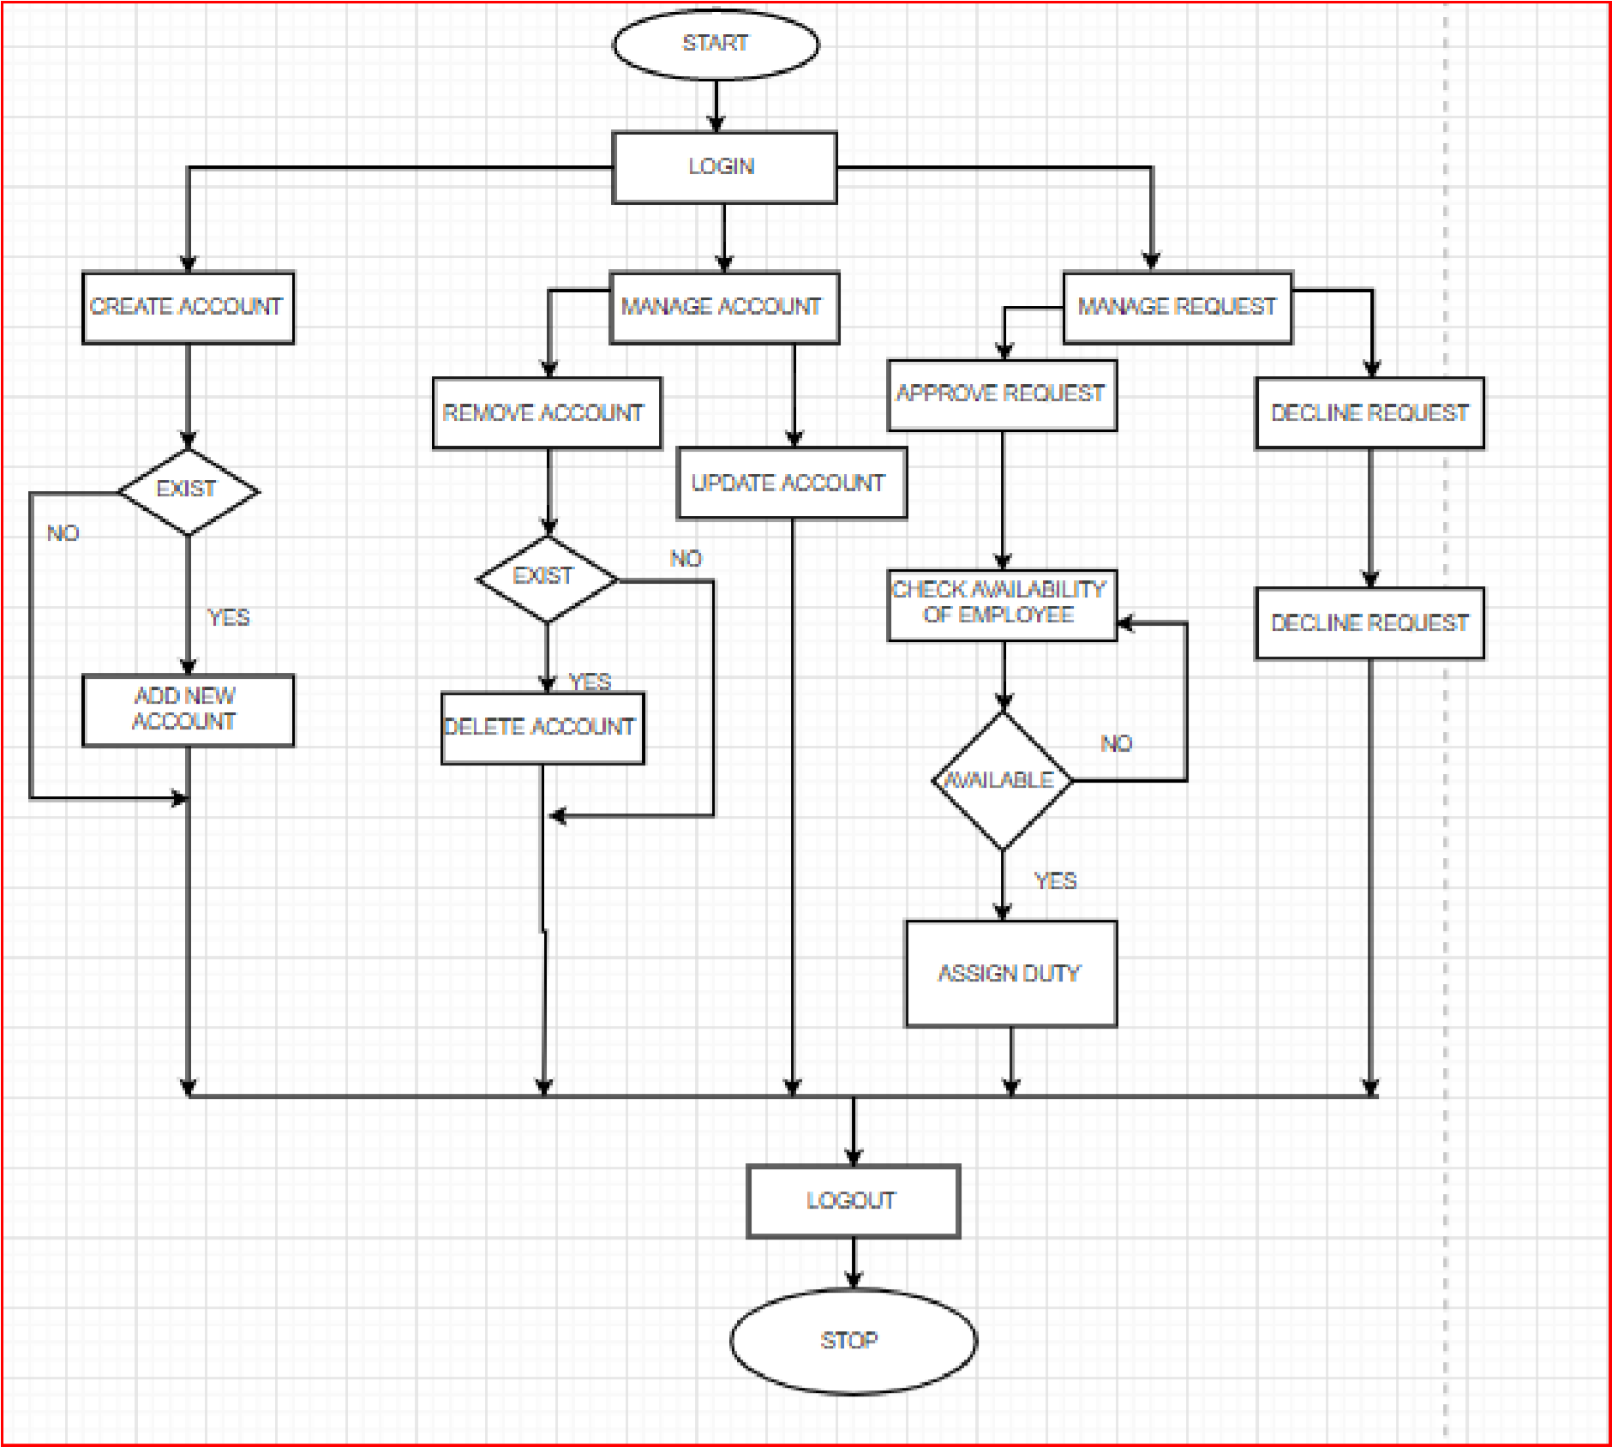

# ALGORITHM:

STEP 1 : Start.

STEP 2 : Login.

STEP 3 : If admin wants to create account click on Create Account.

STEP 4 : If account is existed press YES if not press NO and click on Add new account.

STEP 5 : If admin want to manage account click on Manage account. In manage account admin can update or delete account.

STEP 6 : If admin want to remove account press YES and click on delete account and if not press NO.

STEP 7 : If admin want to update press on update account.

STEP 8 : If admin want to manage quotation click on Manage Quotation.

STEP 9 : If quotation or payment is done admin can remove it press YES and if not press NO.

STEP 10 : Logout.

STEP 11 : Stop.

# ACTIVITY DIAGRAM:

Activity diagram is another important diagram in UML to describe the dynamic aspects of the system.

Activity diagram is basically a flowchart to represent the flow from one activity to another activity. The activity can be described as an operation of the system.

The control flow is drawn from one operation to another. This flow can be sequential, branched, or concurrent. Activity diagrams deal with all type of flow control by using different elements such as fork, join, etc. The basic purposes of activity diagrams is similar to other four diagrams. It captures the dynamic behavior of the system. Other four diagrams are used to show the message flow from one object to another but activity diagram is used to show message flow from one activity to another.

Activity is a particular operation of the system. Activity diagrams are not only used for visualizing the dynamic nature of a system, but they are also used to construct the executable system by using forward and reverse engineering techniques. The only missing thing in the activity diagram is the message part.

It does not show any message flow from one activity to another. Activity diagram is sometimes considered as the flowchart. Although the diagrams look like a flowchart, they are not. It shows different flows such as parallel, branched, concurrent, and single.

The purpose of an activity diagram can be described as − • Draw the activity flow of a system.

• Describe the sequence from one activity to another. • Describe the parallel, branched and concurrent flow of the system.

# 1. MANAGE EMPLOYEE:

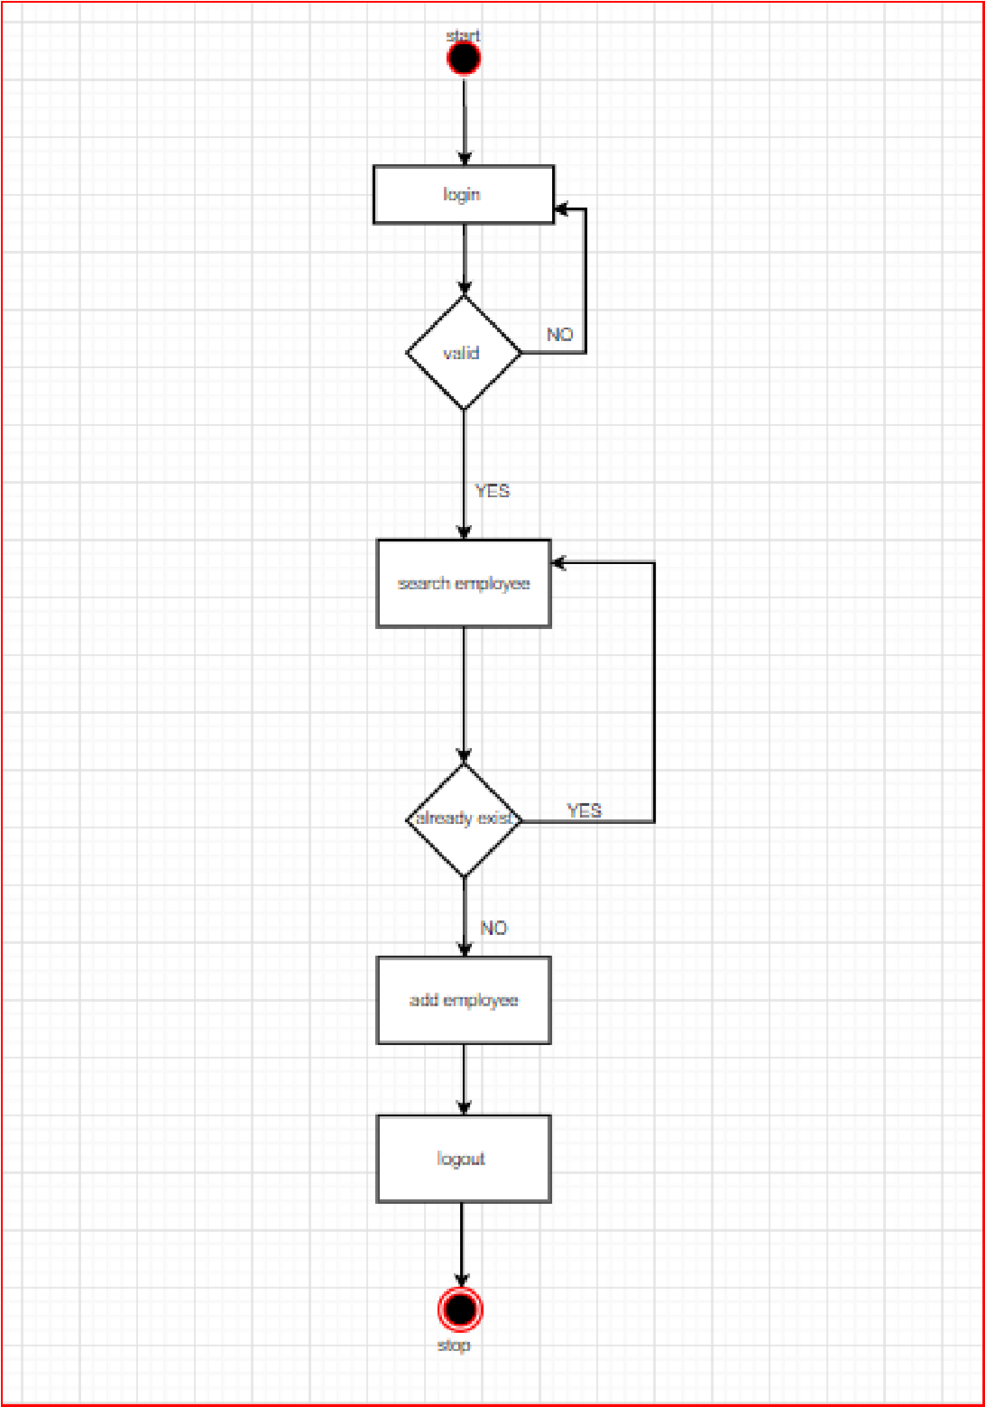

# 2. ASSIGN ATTENDENT:

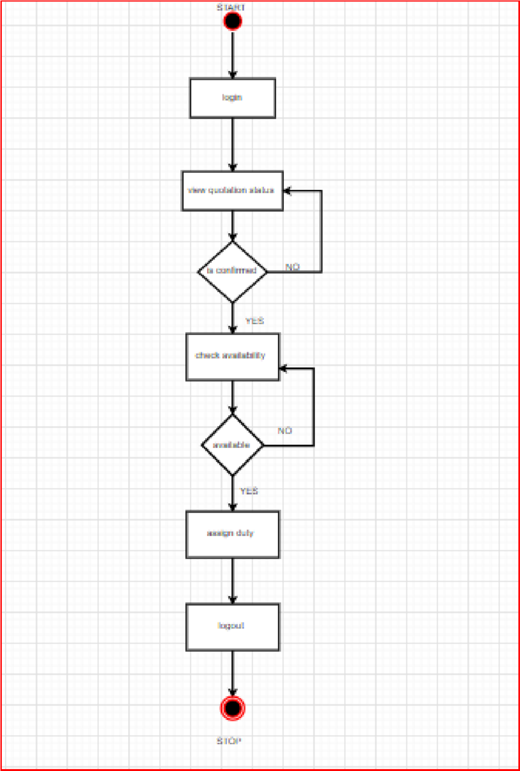

# SEQUENCE DIAGRAM:

A **sequence diagram** is defined by the **UML** Reference **Manual** as “a **diagram** that shows object interactions arranged in time **sequence**. In particular, it shows the objects participating in an interaction and the **sequence** of messages exchanged” . It represents objects as vertical lines and messages as arrows with labels.

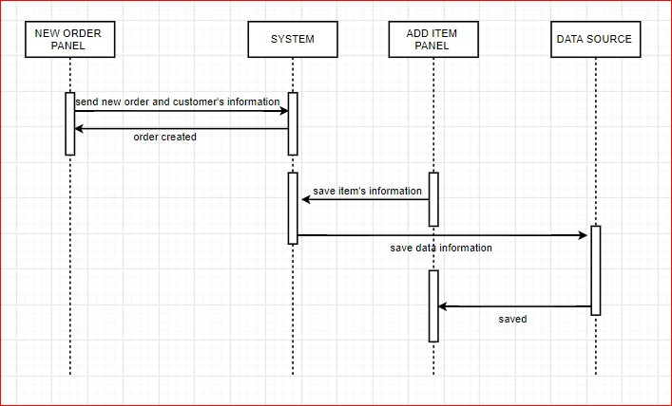

# USE CASE DIAGRAM:

A use case is a software and system engineering term that describes how a user uses a system to accomplish a particular goal. A use case acts as a software modelling technique that defines the features to be implemented and the resolution of any errors that may be encountered.

Three basic elements make up a use case:

* **Actors:** Actors are the type of users that interact with the system.

* **System:** Use cases capture functional requirements that specify the intended behaviour of the system.

* **Goals:** Use cases are typically initiated by a user to fulfil goals describing the activities and variants involved in attaining the goal.

The steps in designing use cases are:

* Identify the users of the system.
* For each category of users, create a user profile. This includes all roles played by the users relevant to the system.
* Identify significant goals associated with each role to support the system. The system’s value proposition identifies the significant role.
* Create use cases for every goal associated with a use case template and maintain the same abstraction level throughout the use case. Higher level use case steps are treated as goals for the lower level.
* Structure the use cases.
* Review and validate the users.

**1. ADMIN:**

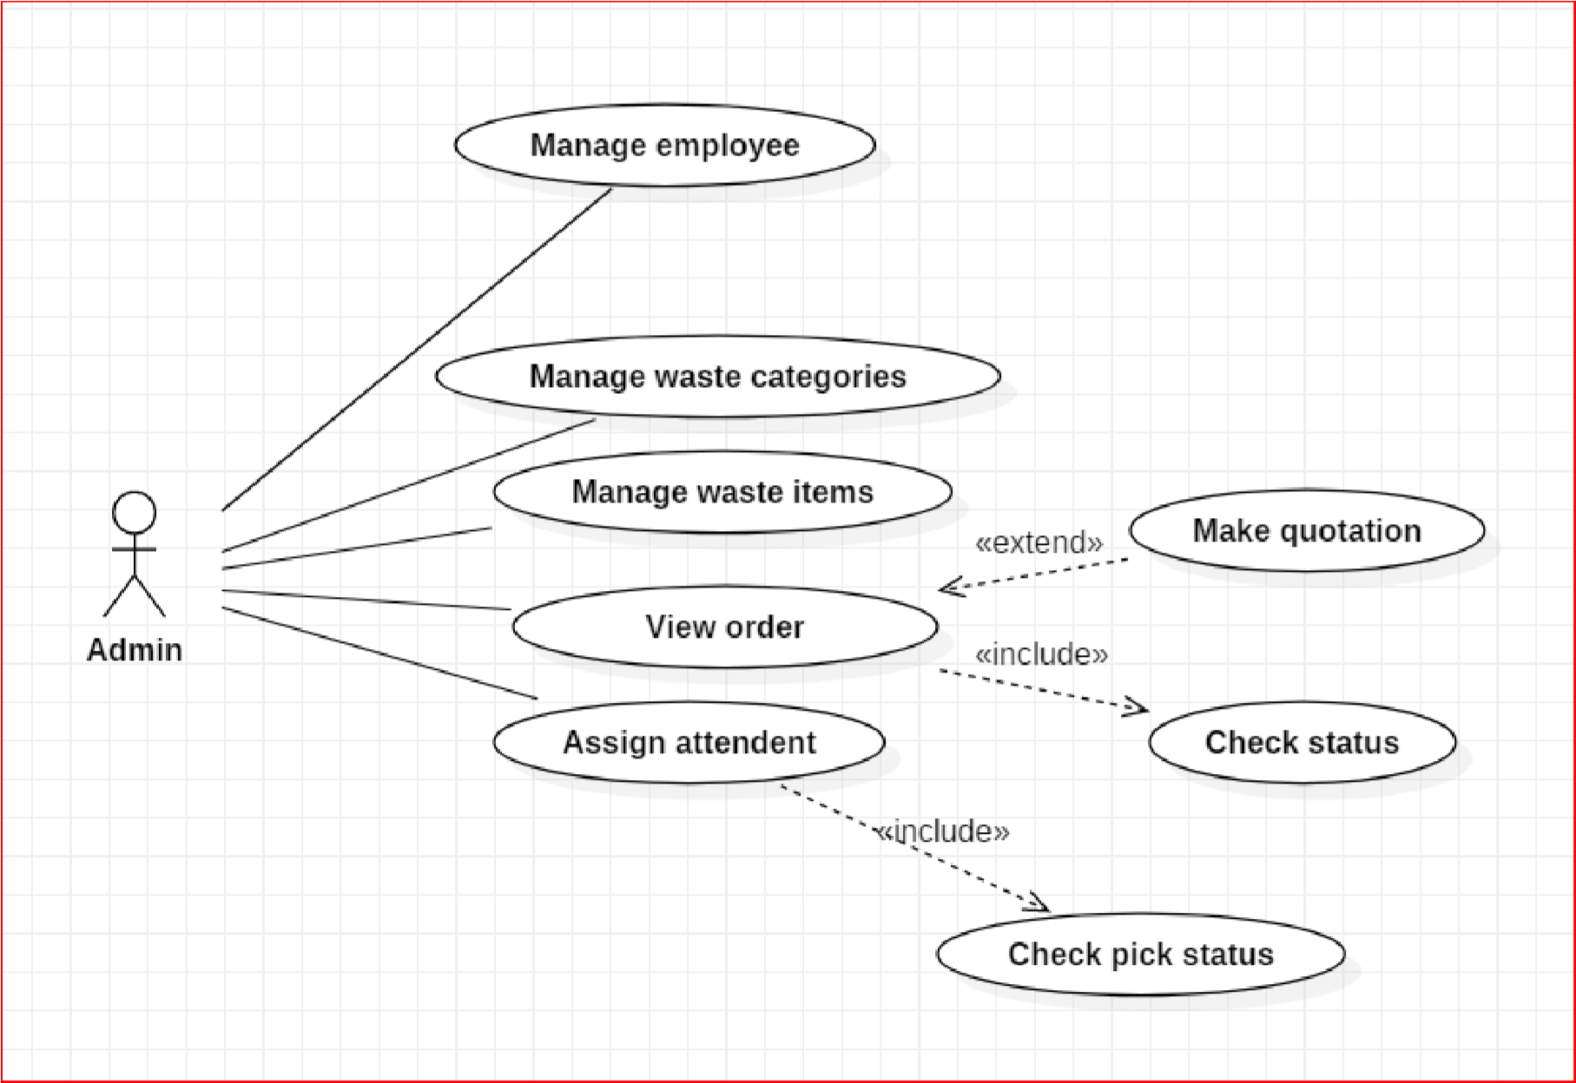

# 2. CUSTOMER:

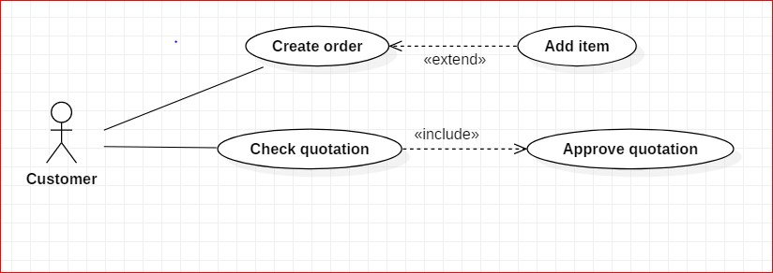

# 3. EMPLOYEE:

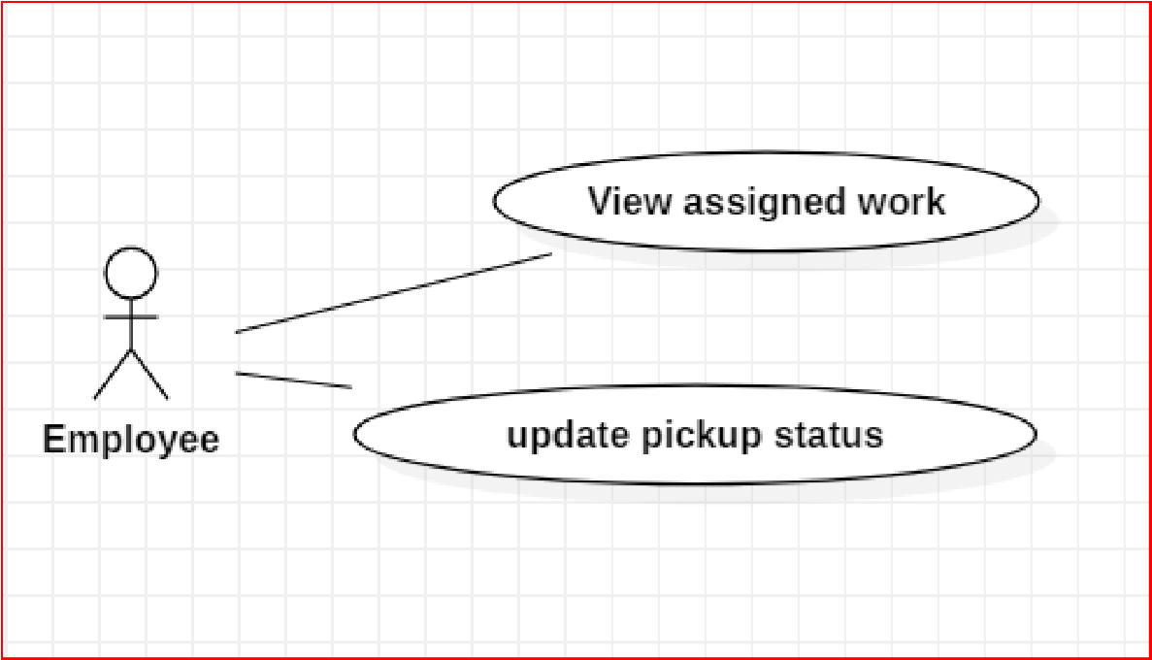

### 4.2.2 DATA STRUCTURES :- TREE DIAGRAM:

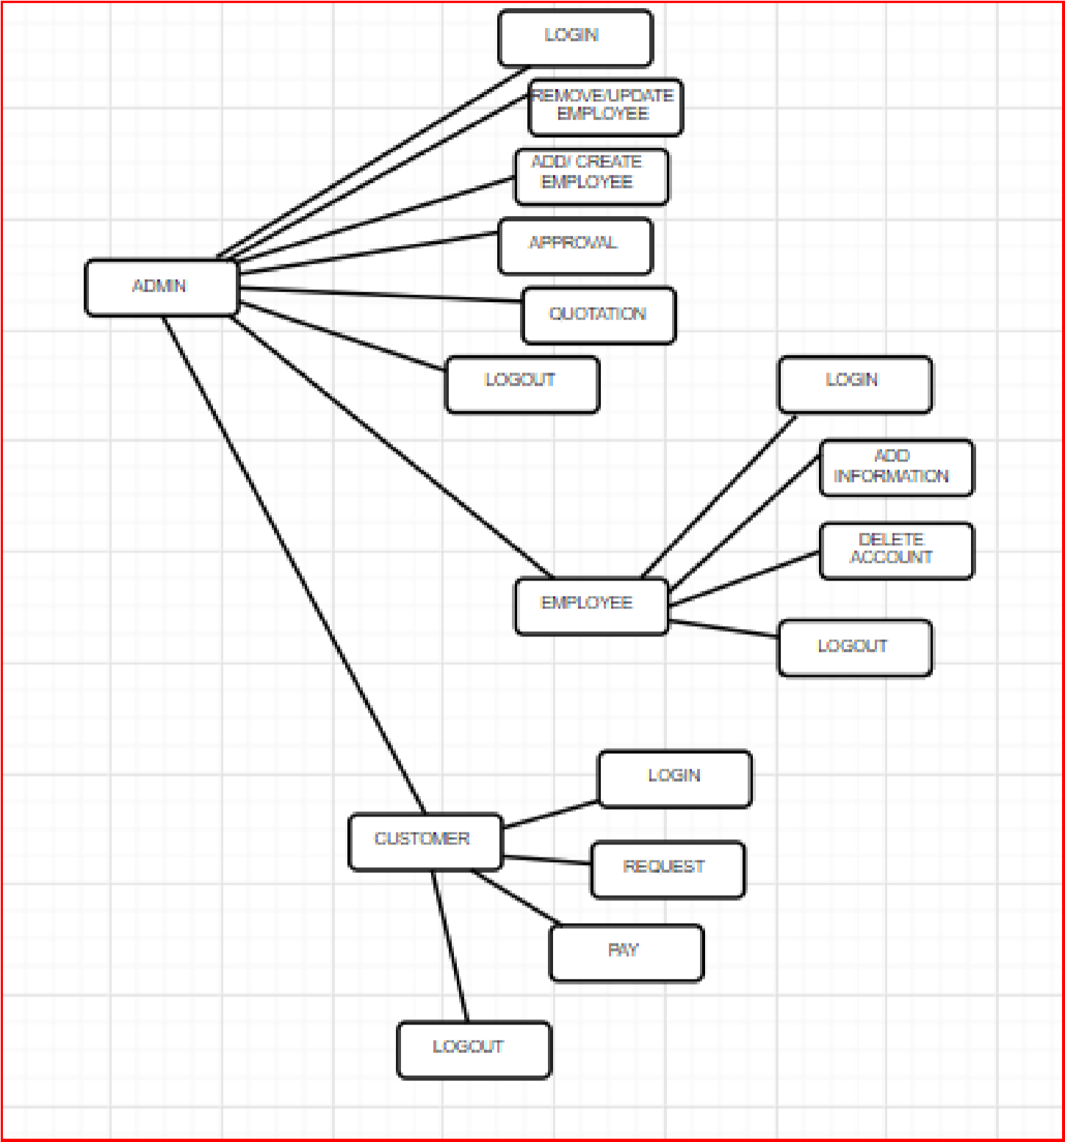

### 4.2.3 ALGORITHM DESIGN :-

# USER LOGIN:-

1. User visit the website.
2. User logins the website.
3. Enter username and password.
4. User clicks on login.

# NEW USER REGISTRATION:-

1. If user don’t have Login ID and Password then customer create a new account.
2. Enter the following details in Register form:- • Username
   * Password
   * Email ID
   * Address
   * Contact Number
3. After the filling details click on Register.
4. After registration user gets mail of registration.

# ADMIN LOGIN:-

1. Admin go to website of E-waste Collection.
2. Go to login page.
3. Enter Username and Password.
4. Click on Login button.
5. After login admin going to the home page.

## 4.3 USER INTERFACE DESIGN :-

# ADMIN LOGIN:

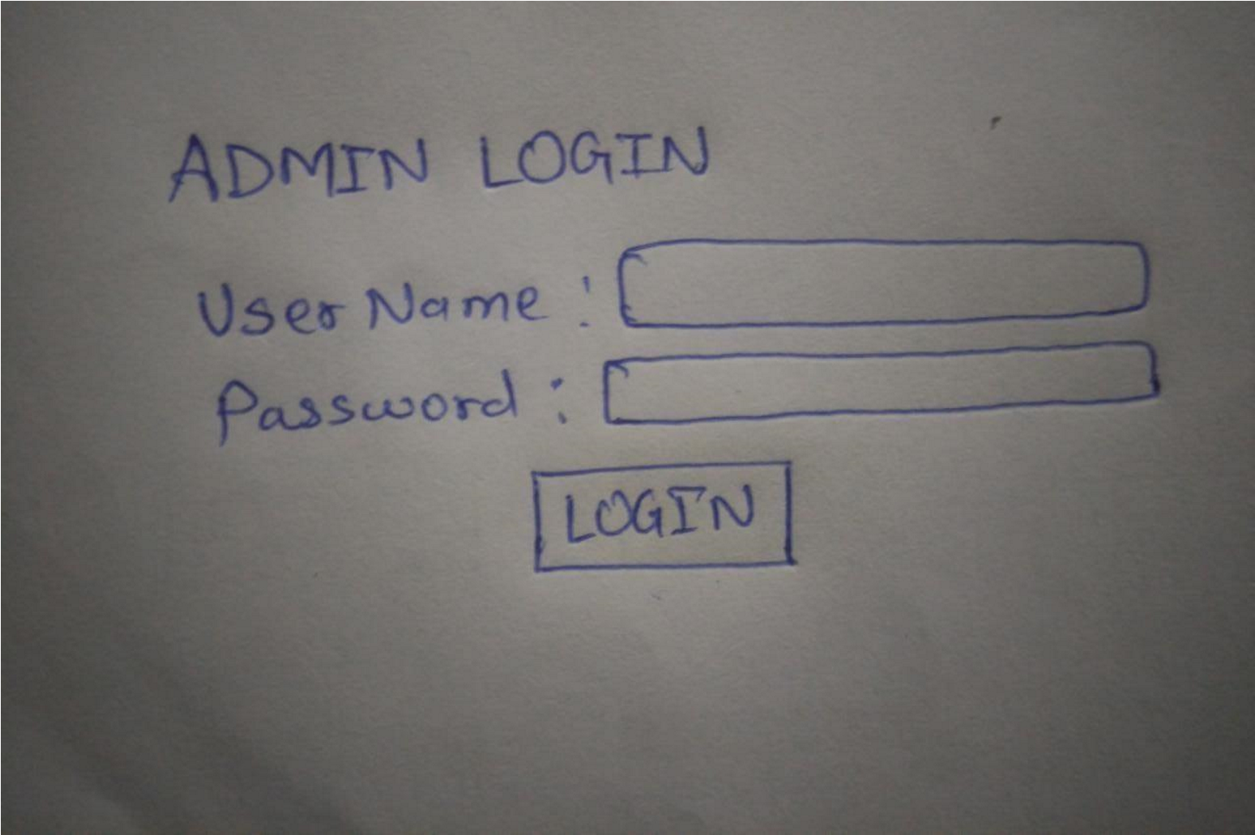

# USER LOGIN:

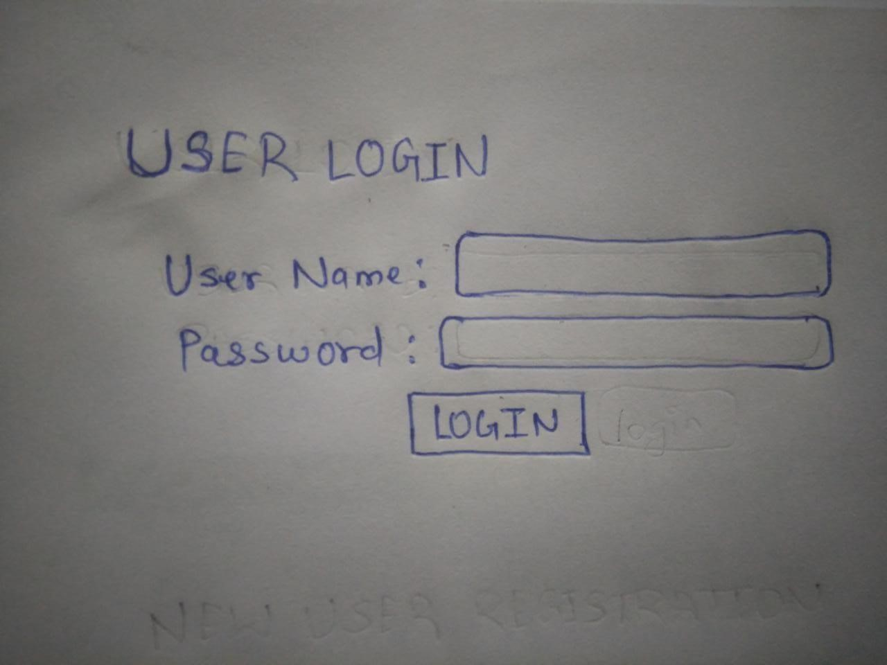

# NEW USER REGISTRATION:

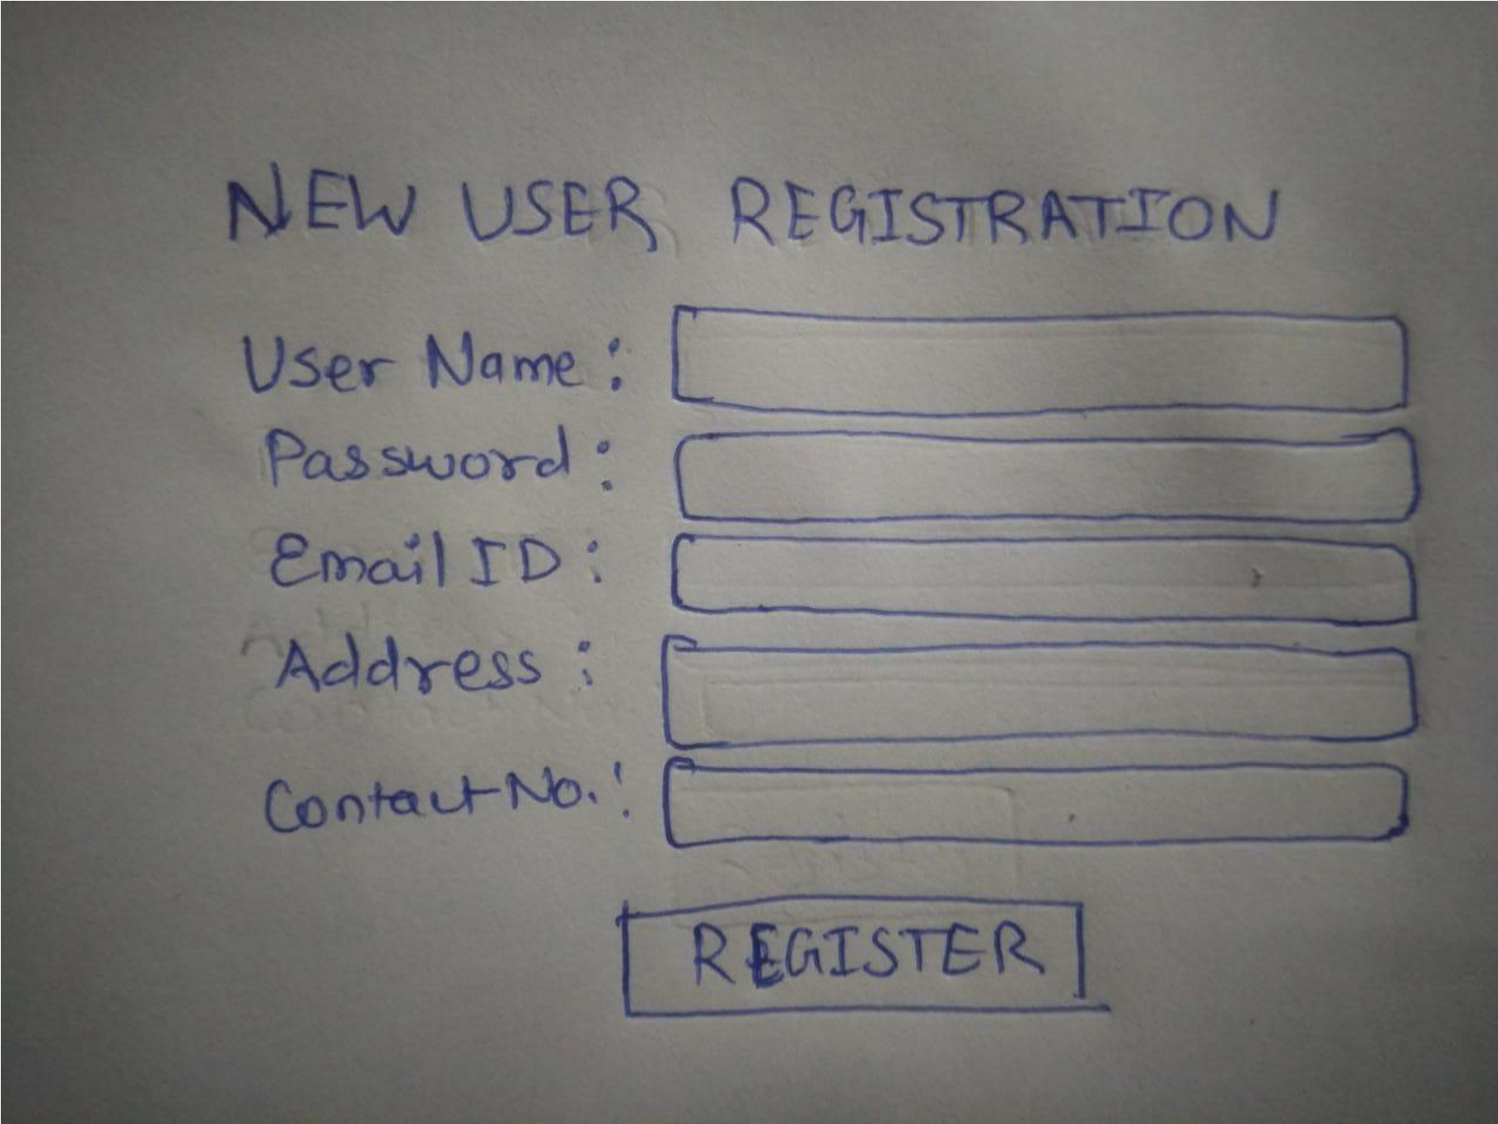

# DASHBOARD:

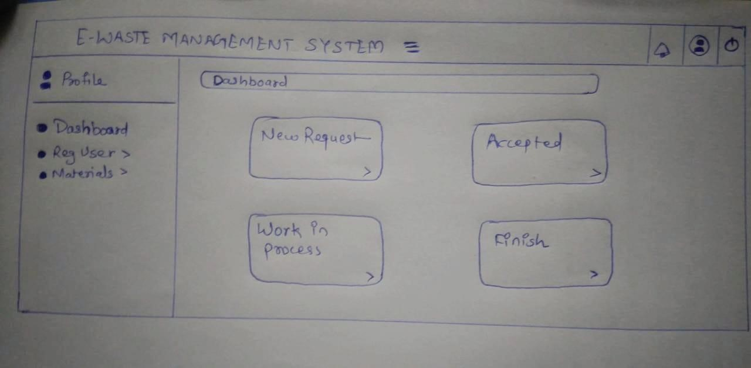

## 4.4 SECURITY ISSUES :- AUTHENTICATION :-

Authentication is the process of determining whether someone or something is in fact who or what it declares itself to be Authentication technology provides access control for systems by checking to see if users credentials match the credentials in a database of authorized users or in a data authentication server.

Users are usually identified with a user ID and authentication is accomplished when the user provides a credential for example a password that matches with that user ID. Most of the users are most familiar with using a password which ,as a piece of information that should be known only to the user is called a knowledge authentication factor.

The payment gateway is a valuable tool necessary to credit card processing for every online business. These gateways are designed to facilitate hundreds or thousands of transactions per day. If you notice an issue with your payment gateway contact your acquiring bank in a timely manner.

## 4.5 TEST CASES DESIGN :- LOGIN PAGE TEST CASE :

|  |  |  |
| --- | --- | --- |
| **Test case ID** | **Test case** | **Excepted results** |
| TC1 | Test if registered user is able to login successfully. | User must be logged in to the web page. |
| TC2 | Test if unregistered users is not able to login to the site. | Proper error must be displayed and prompt enter login again. |
| TC3 | Test with valid username and empty password such that login must get failed. | Proper error message must be displayed and prompt to enter login again. |
| TC4 | Test with empty username and empty password and check if login fails. | Proper error message must be displayed and prompt to enter login again. |

to

|  |  |  |
| --- | --- | --- |
| TC5 | Check of the password is masked on the screen i.e., password must be in bullets or asterisks. | The password field should display the characters in asterisks or bullets such that the password is not visible on the screen. |

# VALIDATION TEST CASE:

|  |  |  |
| --- | --- | --- |
| **Test case Id** | **Test case** | **Expected Result** |
| TC1 | Enter empty value for a e-waste textbox and click the add button | When the field is empty an appropriate validation  message will be displayed -” Please enter correct e-waste material details to add” |
| TC2 | Enter empty value for e-waste description or no photo uploaded and click the add button | When the field is empty an appropriate validation message will be displayed -” Please enter description details and an image of your  waste material to add” |
| TC3 | Click any delete/update button of a grid view. | A pop-up box should appear to show the message” deleted/updated a row from the grid view successfully. |